Mandatory Template 3: Notification regarding the Board of Management’s review of the Child Safeguarding Statement

To: The Diocese of Ardagh and Clonmacnois.

The Board of Management of Lumcloon NS wishes to inform you that:

• The Board of Management’s annual review of the school’s Child Safeguarding Statement was completed at the Board meeting of 9/9/25.

• This review was conducted in accordance with the “Checklist for Review of the Child Safeguarding Statement” published on the gov.ie website

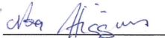
Signed Date 9/9/25

Chairperson, Board of Management

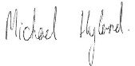
Signed Date 9/9/25

Principal/Secretary to the Board of Management

